**AI IN DEFENCE SYSTEM OF INDIA**

Introduction:

* As AI is becoming popular in this today’s world there’s also increased in its need.
* Today AI is utilized by Healthcare Systems, Logistics System, and Military Systems. It is also said that AI will play major role in Industry 4.0.
* It has capability of bringing significant transformations in the way human’s activities and military operations are conducted

Need Of AI:

* The Russian President Vladimir Putin stated that “Whichever country leads the way in Artificial Intelligence research, will be the ruler of the world in the 21st Century.”
* As Other countries like USA, Russia, China are working on making their defense System Strong using AI.
* India will also have to use AI to secure itself.

Existing Technologies and upgradation:

* India is already using AI in defense like ISR system from decades.India’s ISR capabilities include space-based ones like INSAT, Indian Remote Sensing Satellite, Radar Imaging Satellite, aerial ones like UAVs that include Lakshya, Nishant, Kapothaka and aircraft and helicopters and AEWACS and many more.
* But there are many challenges coming up to India. Recently, Times Of India published an Article on 8th of February 2020 which states that India is not Prepared for “Swarms Of Drones” attack.

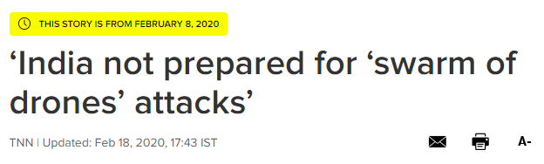

* India will also need to adapt newer technology using AI. So India can defend and attack smartly in coming time.

Newer AI technologies to be developed:

* To come up with such kind of situation where opposition’s UAV creates havoc in India, for these India has already started developing newer small war drones like DRDO Rustom series, Harop, Heron TP etc. India also Collaborated with USA to make newer war drones.
* But India is preparing for either to defend or attack at border.

Main Threat:

* But what, when the terrorists who crosses the border and plan an attack in India. It will be a best practice to trace the terrorist at border and to catch them. For these we can use AI for the surveillance from which we can stop terrorists to enter the Indian borders.
* We can see from the article published by Zee news on 21st of June, 2020. This says that terrorist entered the Indian region from truck which is threat to Indian Capital Delhi.

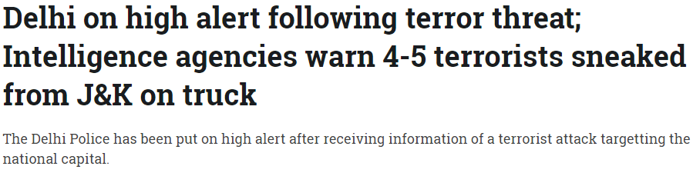

* Also statista released a survey in which it states that India is 21% worried about terrorism, where lives matters this number seems to be big.

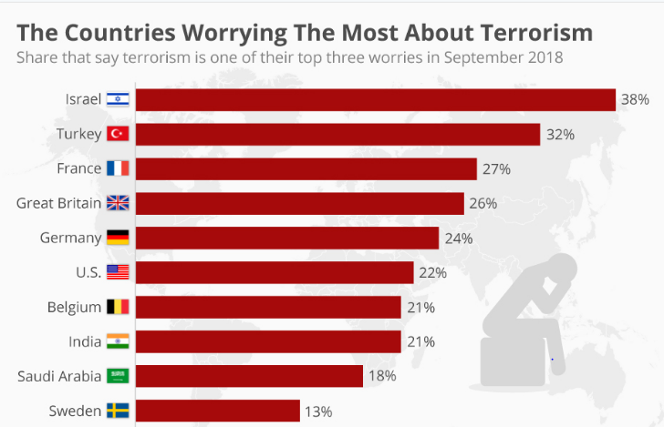

Solution:

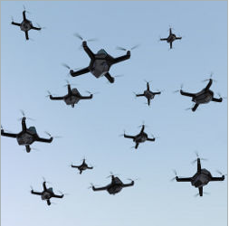

Swarm Of Drones

* For surveillance India has a BOSS(Border Surveillance System) system. We can enhance this BOSS System by using Swarm of Surveillance drones which will have capability of analyzing threat. Once threat is verified we can make use of autonomous or unmanned robots to point at target.
* We can deploy it on the borders so it will totally become impossible for terrorist to enter India.
* The threat analysis algorithms will train the drones using various threat videos from which it will predict the threat on borders. Also, we can apply cybersecurity algorithms will help for analyzing network threat detection and prevention on drones which can be achieved by using Random Forest, decision trees, Support vector machines and deep learning algorithms.
* From these unethical hackers will not be able to hack these drones.
* On the hardware front, It will have smaller camera,fastest AI processing chips like Arm Cortex-M55 processor, Arm Ethos-U55 NPU to process the data.
* This Surveillance Flying drones will be energy efficient.
* These drones will have ability to sense the environment and to communicate with other drones from which it will be not possible to catch these small drones.
* This drones will have many other features which will help the Indian Defense System to make India threat free in future.

Problems with UAV: -

* Safety is a primary concern when dealing with unmanned aerial vehicles.  In the event of system failures, falling drones are another serious danger ,especially when they are used near large crowds.
* Another main concern when using UAV is hardware of UAV. We never know when the system’s hardware will crash.
* The major problem with crashed UAV is that once its goes to wrong hand there will be problem of Information leak.
* The main threat is related to the issue of private property surveillance, where drones can be easily used to breach the physical privacy of people.
* According to BBC News , smuggling drugs, phones, and even blades to prisoners within highly secure prisons, were being carried out while avoiding ground detection. This is typically achieved via an drone that is capable of lifting. Moreover, such attacks include crashing drones into certain people intentionally or crashing them into people’s properties, which may cause low to serious damages.
* UAV-Surveillance is a new method used by terrorists to capture live footage while planning an attack.
* Also, Airstrike Disruption is a technique which was adopted by ISIS to disrupt airstrikes. In this they wait on their opponents to fly a drone, then ISIS operators would fly and target the airstrike calling team, tricking their opponents into thinking its a friendly drone hovering overhead. Such drones were of 10 armed with 40-mm grenade-sized munitions and can hit their target with high accuracy